**QUE-26.3.1- Create table RealEstate in Hive database, with all the columns present in dataset.**

**ANS-26.3.1-**

**INPUT-**

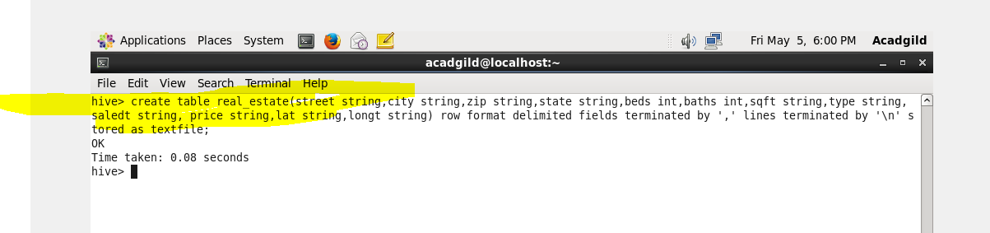

**Output-**

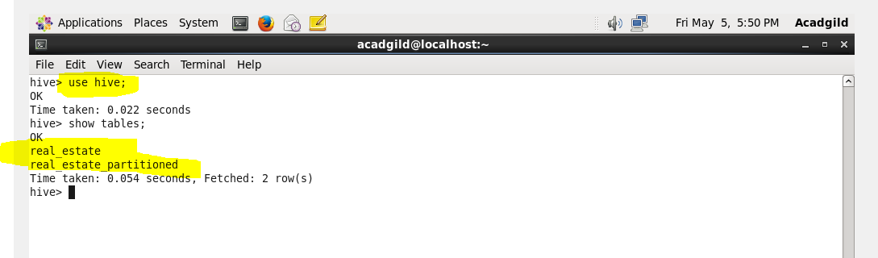

**QUE-26.3.2- Load dataset into table realEstate.**

**ANS-26.3.2-**

COMMANDS-

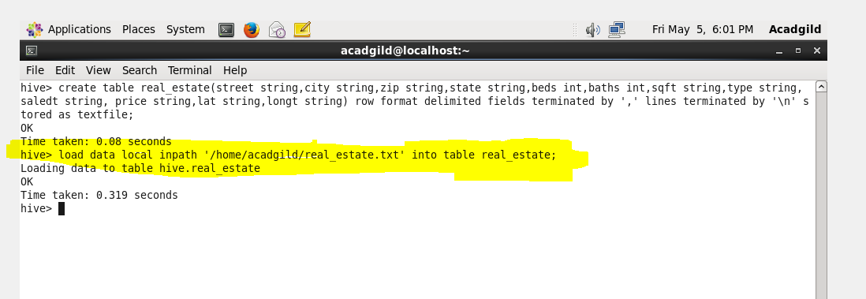

**Output -**

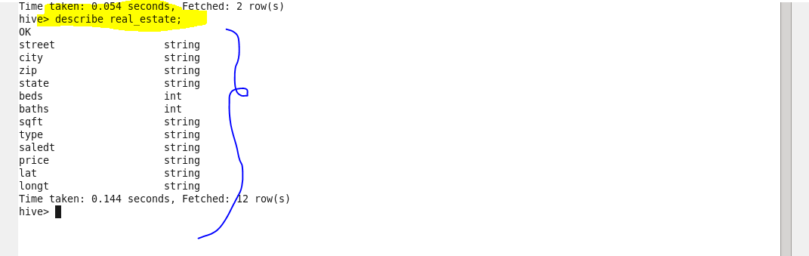

**QUE-26.3.3- Using Dynamic partition get separate lists of residential apartments with more than 2 beds and include columns in following order City,Baths,Sq_feet,Price,flat_type,Beds respectively**

**ANS-26.3.3-**

**Dynamic partitioning-**

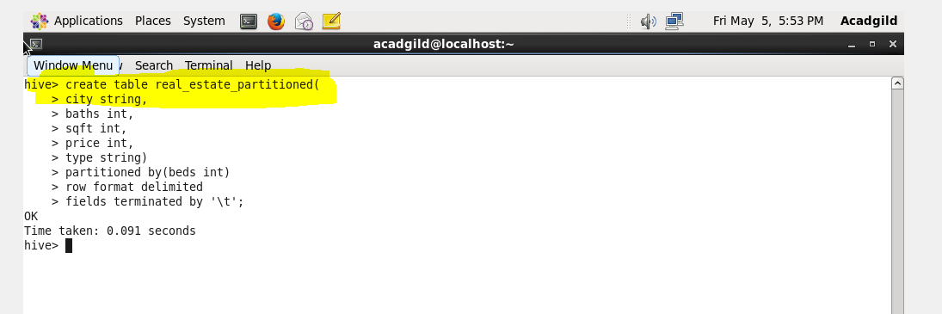

**Output -**

